

**Project Report**

Developing a Hotel Management Web Application

**Developed By :**

*Fares RABBOUDI*

**From** 14/3/2024 **to** 14/4/2024

**Supervised by:**

Mr. Heithem Abbes

Table of Contents:

*I.* *Project Overview :* 4

1. Objectives: 4

2. Technologies Used: 4

*II.* *Database Layer :* 4

1. Overview: 4

2. Database Diagram: 4

*III.* *Backend Layer :* 5

1. Database Connection: 5

2. Backend Architecture: 5

a. Model Layer: 6

b. Repository layer: 11

c. Service Layer: 13

d. Controller Layer: 17

3. Security Configuration: 25

a. Overview: 25

b. WebConfigurationSecurity.java: 26

c. Registration & Authentication: 28

*IV.* *API Testing with Swagger & Postman :* 33

1. Swagger: 33

a. Integration: 34

b. Showcase: 35

2. Postman: 36

*V.* *Frontend Layer :* 37

1. Connection with the Backend: 37

2. Showcase: 38

# *Project Overview :*

## Objectives:

The objective of this project is to develop a hotel room reservation management system using the features provided by the Spring framework. The platform aims to allow users to search, book, and manage hotel rooms online, ensuring a smooth and secure experience. Additionally, APIs will be tested using Postman, an interactive documentation will be provided via Swagger, and the frontend can be developed using React.

## Technologies Used:

* ***Spring Boot:*** Used to simplify configuration and deployment.
* ***Spring MVC:*** Implements the MVC model to manage user interactions.
* ***Spring Data:*** Interacts with the database using Spring Data JPA.
* ***Spring Security:*** Ensures the security of the platform.
* ***Postman:*** Tests the developed APIs.
* ***Swagger:*** Generates interactive API documentation.
* ***React:*** Optionally used for frontend development.

# *Database Layer :*

## Overview:

For the database layer of the project, I utilized MySQL as the database technology. MySQL is a widely-used relational database management system known for its reliability, scalability, and performance. The database schema was designed to accommodate the requirements of the hotel reservation system. Three main tables were created: **users** to store user information including name, email, password, and role; **rooms** to store details about the hotel rooms such as room number, type, price, capacity, description, and availability dates; and **reservations** to manage reservations made by users, including references to the user and room IDs, arrival and departure dates, and reservation status. ForeignKey constraints were applied to ensure data integrity and consistency within the database.

## Database Diagram:

# *Backend Layer :*

## Database Connection:

To establish a connection to the MySQL database, I utilized the **application.properties** file in my Spring Boot project. Within this file, I configured the database URL, username, and password using the spring.datasource.url, **spring.datasource.username**, and **spring.datasource.password** properties, respectively. Additionally, I specified the driver class name for MySQL using **spring.datasource.driver-class-name**. For Hibernate configuration, I set the dialect to MySQL using **spring.jpa.properties.hibernate.dialect**. Finally, I enabled SQL logging with **spring.jpa.show-sql=true** and configured Hibernate to automatically update the database schema with **spring.jpa.hibernate.ddl-auto=update**. These settings facilitated seamless integration with the MySQL database and ensured efficient communication between the Spring application and the database.

## Backend Architecture:

In the backend architecture, we've adopted a layered approach following the Model-View-Controller (MVC) pattern. This design separates concerns into distinct layers: Model, Repository, Service, and Controller. The Model layer encapsulates the data entities like users, rooms, and reservations. Repositories handle database interactions, leveraging Spring Data JPA for CRUD operations. The Service layer implements business logic and coordinates actions between controllers and repositories. Lastly, the Controller layer defines RESTful endpoints using Spring MVC, enabling client interactions. This architecture promotes modularity, scalability, and maintainability of the backend codebase.

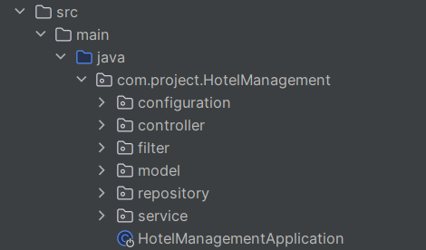

Here is a detailed overview of each layer:

### Model Layer:

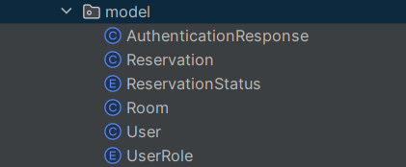

In this layer we implement the entities of our backend which are representations of our database tables in the backend layer of our project, Note that there is an “AuthenticationResponse” model, we will discuss this model later on in the Security section of this report. So lets view our different models one by one:

#### User Model:

This model represents the Users table we have in our database: it consists of the attributes of attributes which are connected to the different columns of the Users table, as well as Getters and Setters to modify and retrieve said attributes:

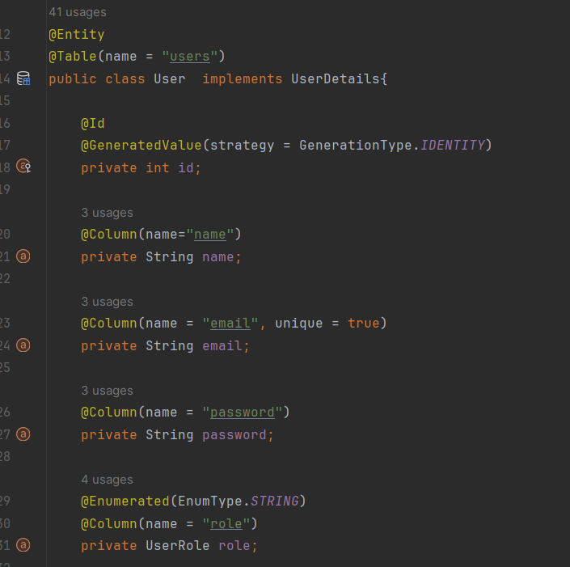

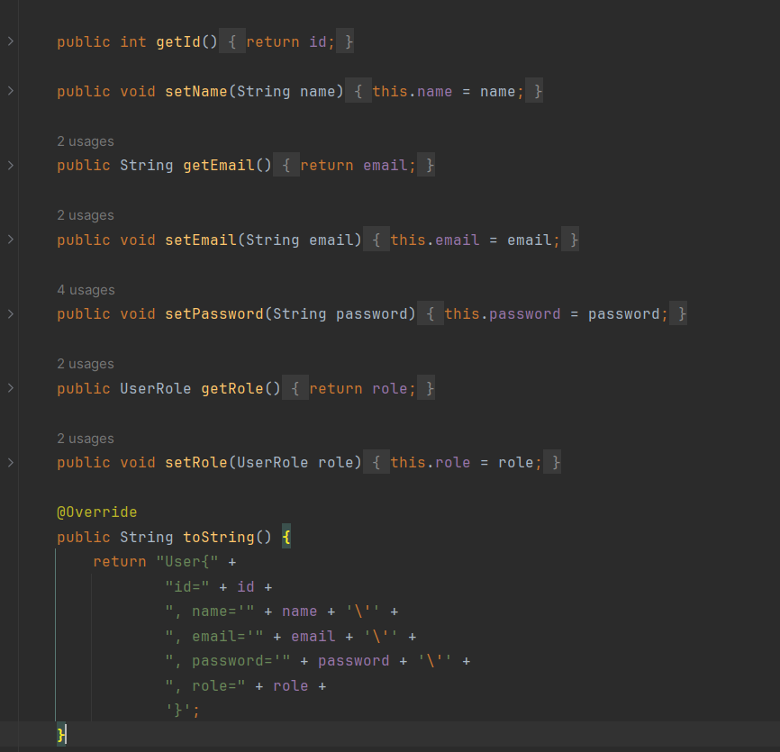

This Entity also Extends from the UserDetails predefined class in Spring Boot and thus overrides methods that we will use for security Purposes so we will discuss them in that section.

#### Room Model:

Similar to the User model, this model acts as the Rooms table representation in our backend layer:

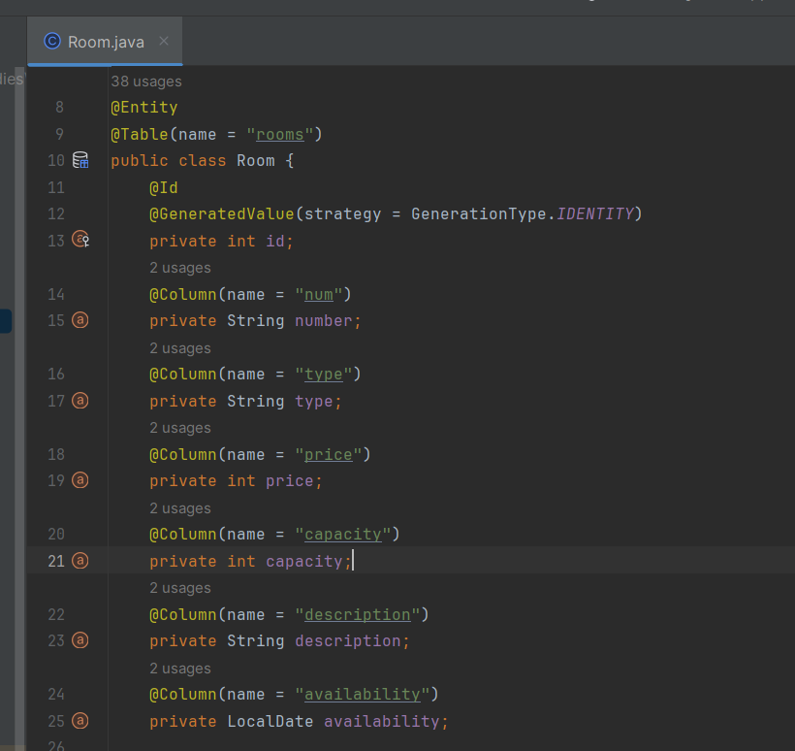

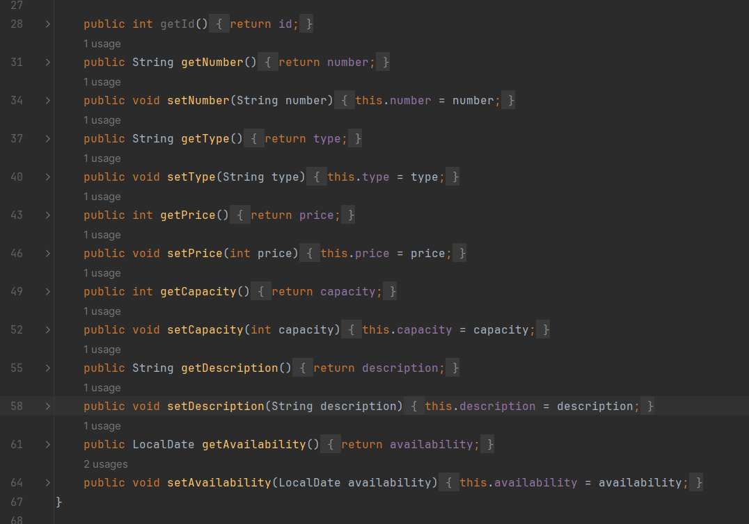

#### Reservation Model:

This Model represents the Reservations table in our backend layer, this table has foreign key constraints because it is linked to both the Rooms and Users table, that link is shown using th @JoinColumn annotation :

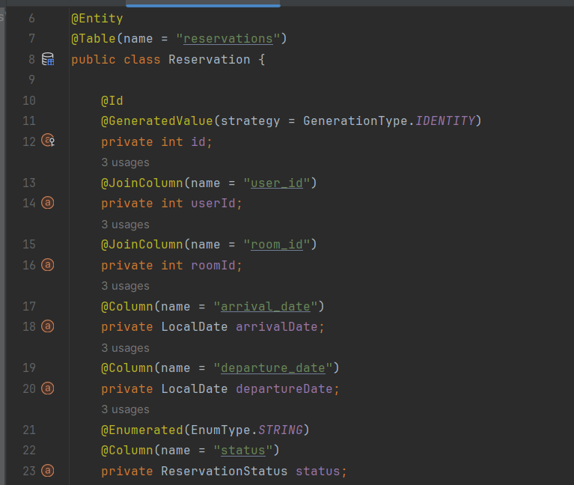

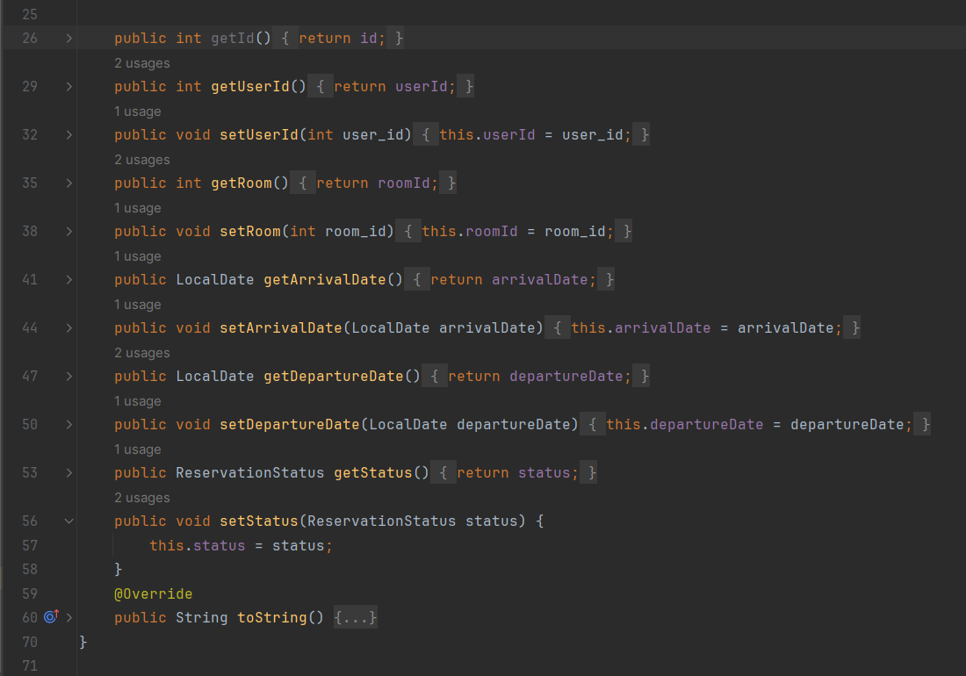

### Repository layer:

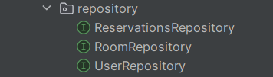The repository layer in the application serves as an intermediary between the business logic layer and the data access layer, encapsulating the logic for interacting with the database and providing methods for CRUD (Create, Read, Update, Delete) operations on entities.

By default the Repository Interfaces provide some pre-coded CRUD functions such as **findById**,**save**,**delete** but I added some functions on top of those:

#### User Repository:

In this Repository I added 2 search methods, findByEmail and findByName:

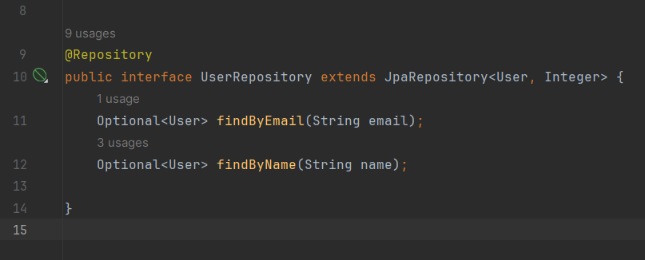

#### Room Repository:

In this Repository I added the following methods:

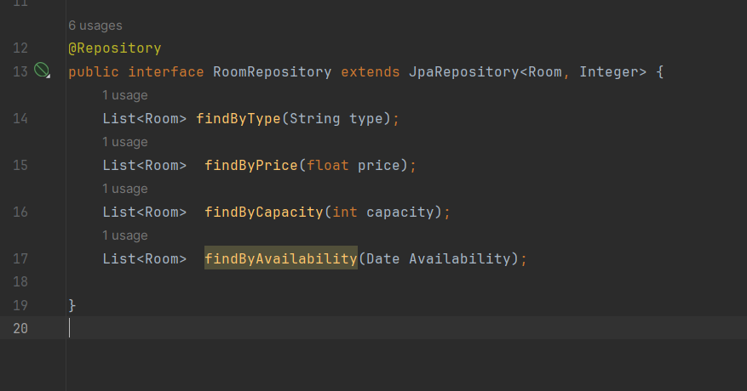

#### Reservation Repository:

And in this Repository, I added the possibility to search for a specific user’s reservations and search for reservations for a certain room:

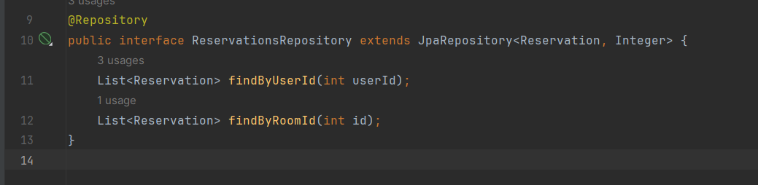

### Service Layer:

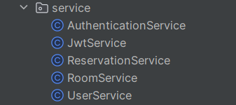The service layer in our application encapsulates business logic and facilitates communication between the repository layer and the controllers, ensuring efficient handling of requests and responses while maintaining separation of concerns.

#### User Service:

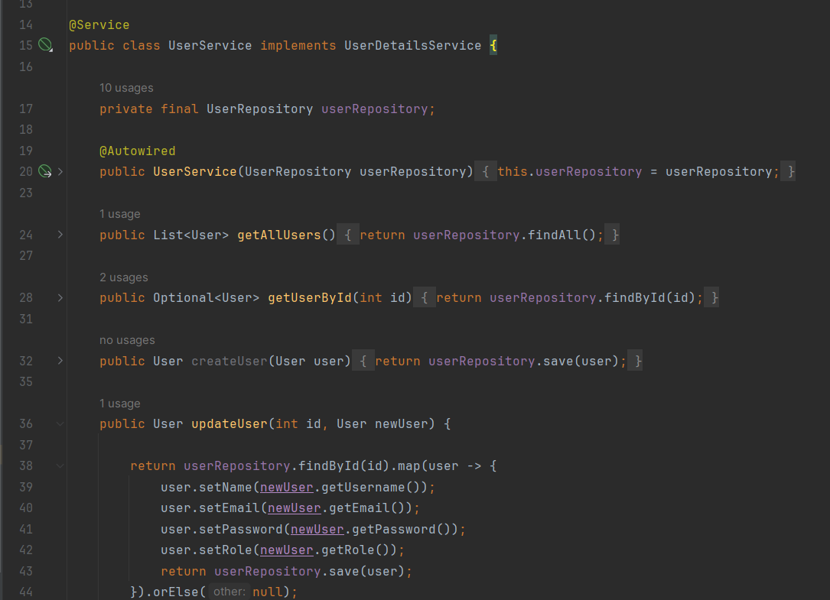

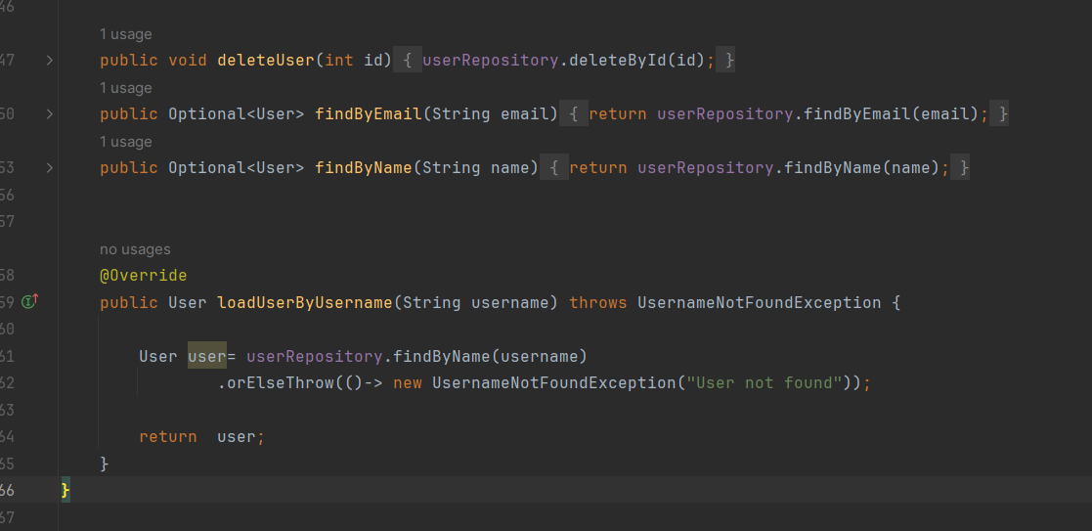

#### Room Service:

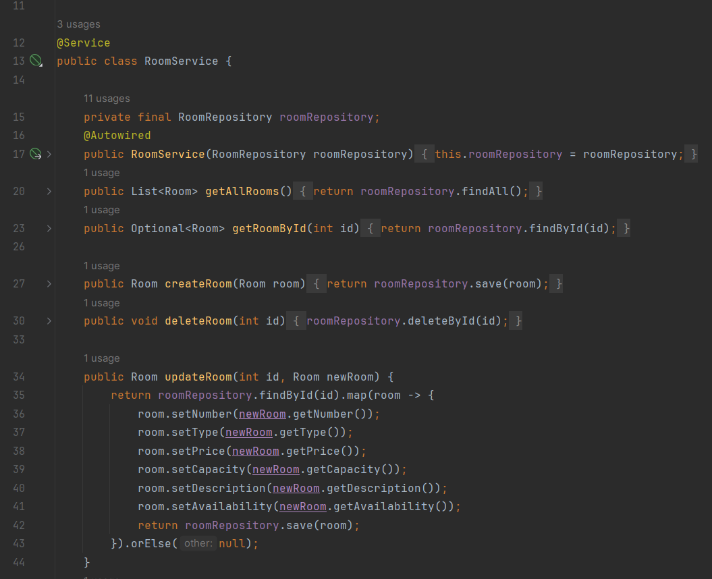

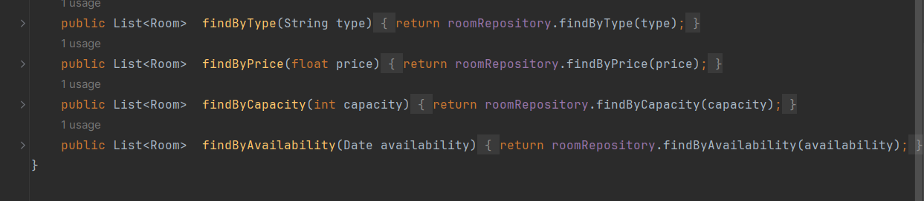

#### Reservation Service :

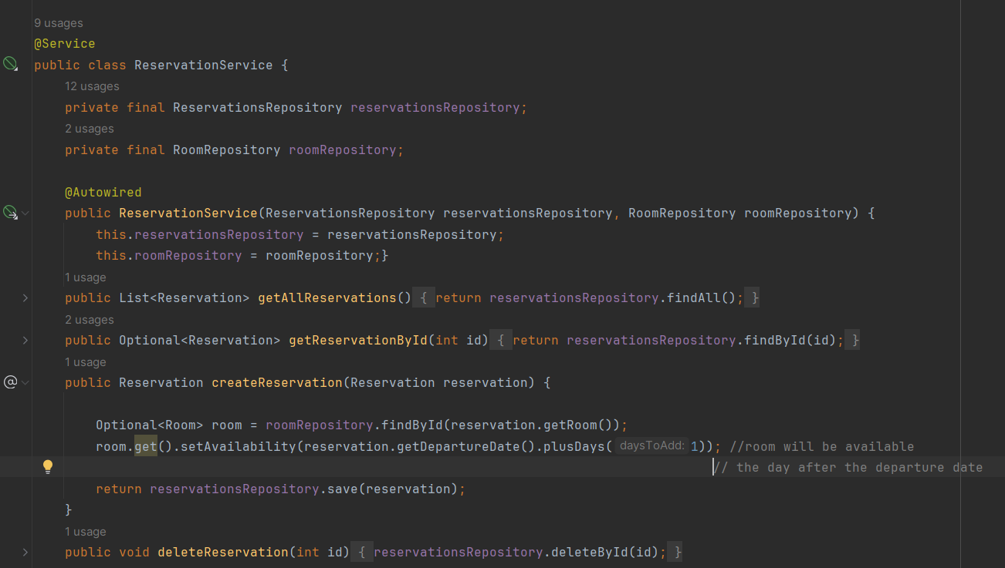

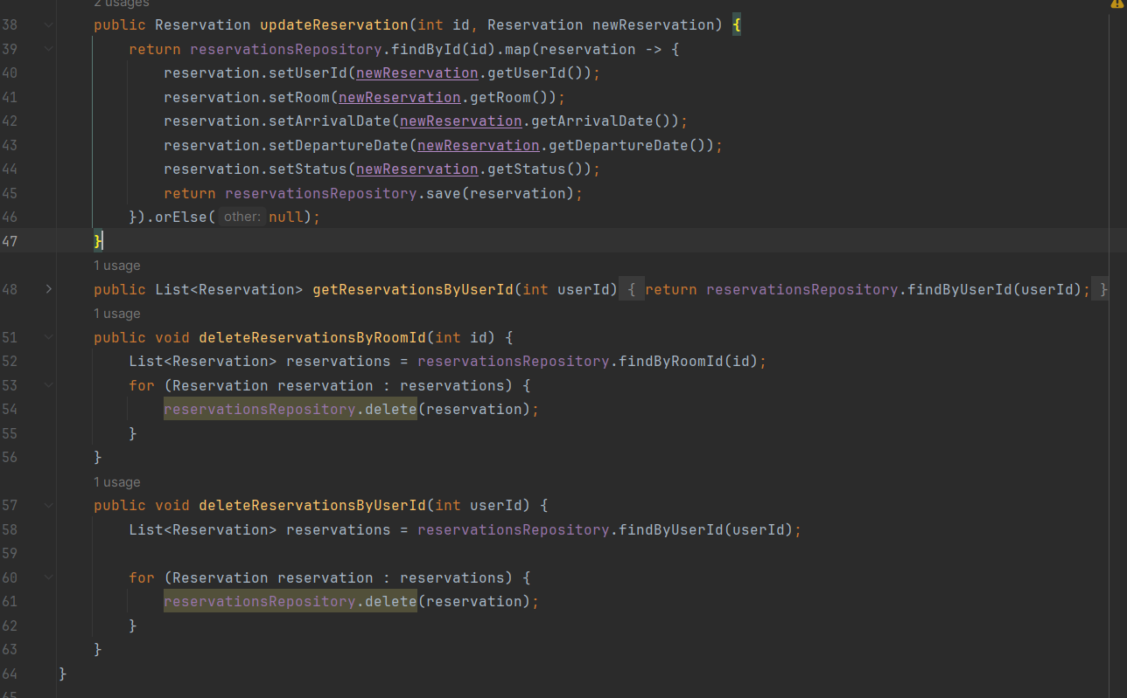

### Controller Layer:

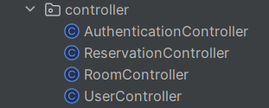The controller layer acts as the entry point for incoming requests, orchestrating the flow of data between the client and the server. It handles incoming HTTP requests, invokes appropriate service methods, and prepares responses to be sent back to the client, ensuring proper handling of user interactions with the application.

Each controller is annotated with these 2 annotations :

***@RestController*** .ndicates that is class is a rest controller.

***@RequestMapping(“{Endpoint}”)*** specifies the endpoint that this controller is assigned to.

Each Controller contains methods annotated with the specific type of HTTP request it is support to handle:

***@GetMapping*** to handle GET requests.

***@PostMapping*** to handle POST requests.

***@PutMapping*** to handle PUT requests.

***@DeleteMapping*** to handle DELETE requests.

#### User Controller:

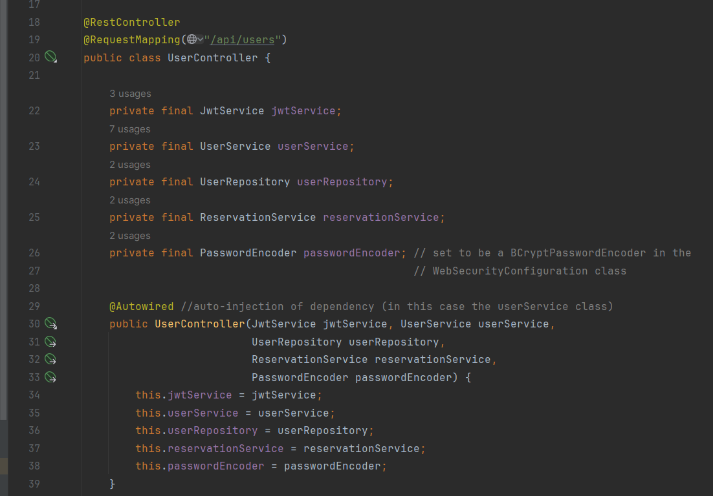This Rest Controller handles all the upcoming requests that target the users in our database, any CRUD operation request is passed to this controller in order to execute the appropriate function based on the accessed endpoint.

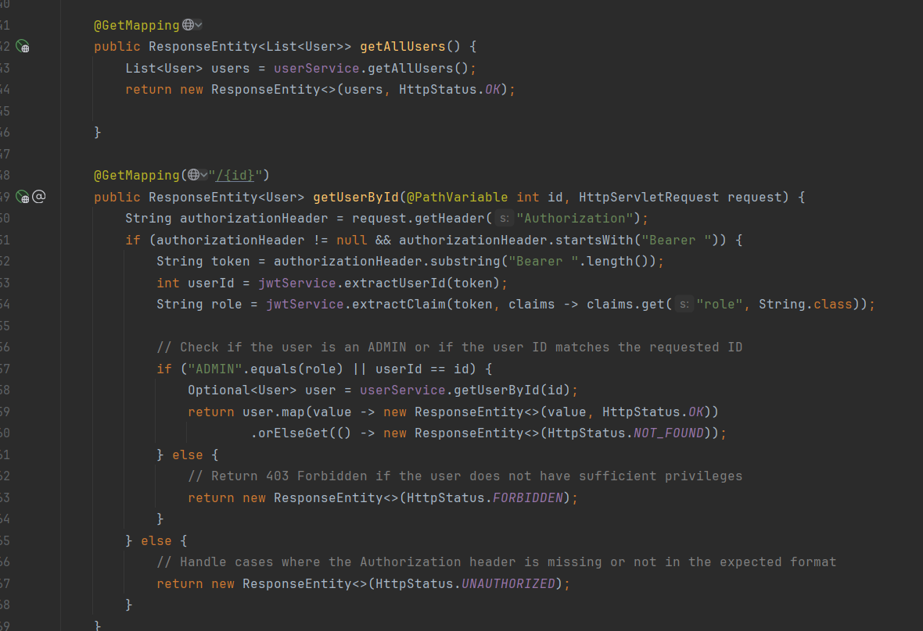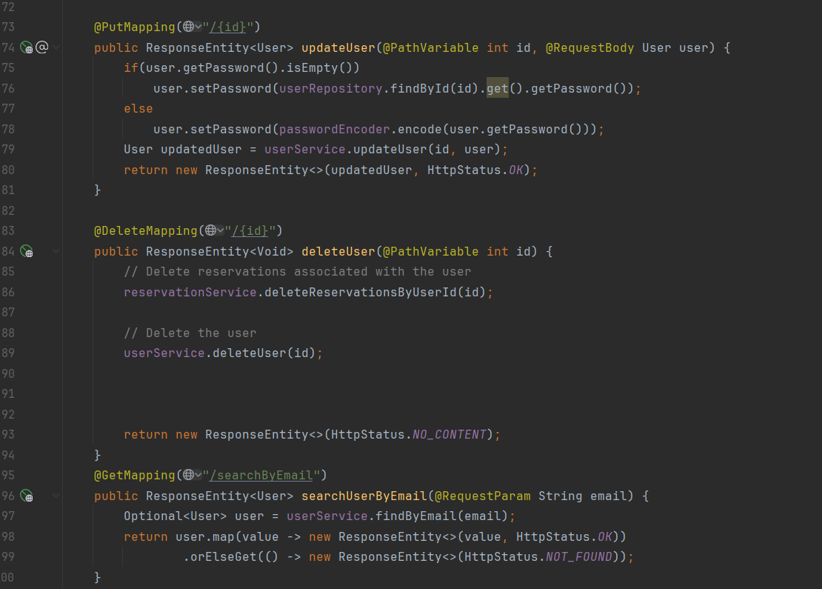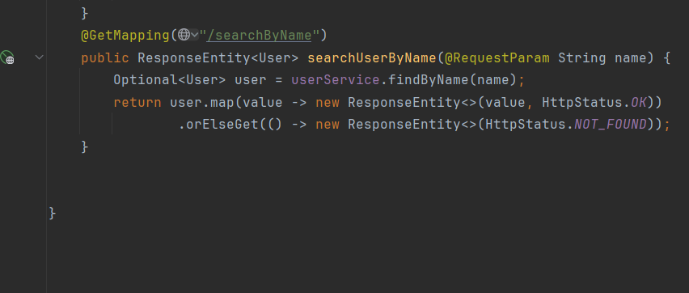

#### A screen shot of a computer program Description automatically generatedRoom Controller:

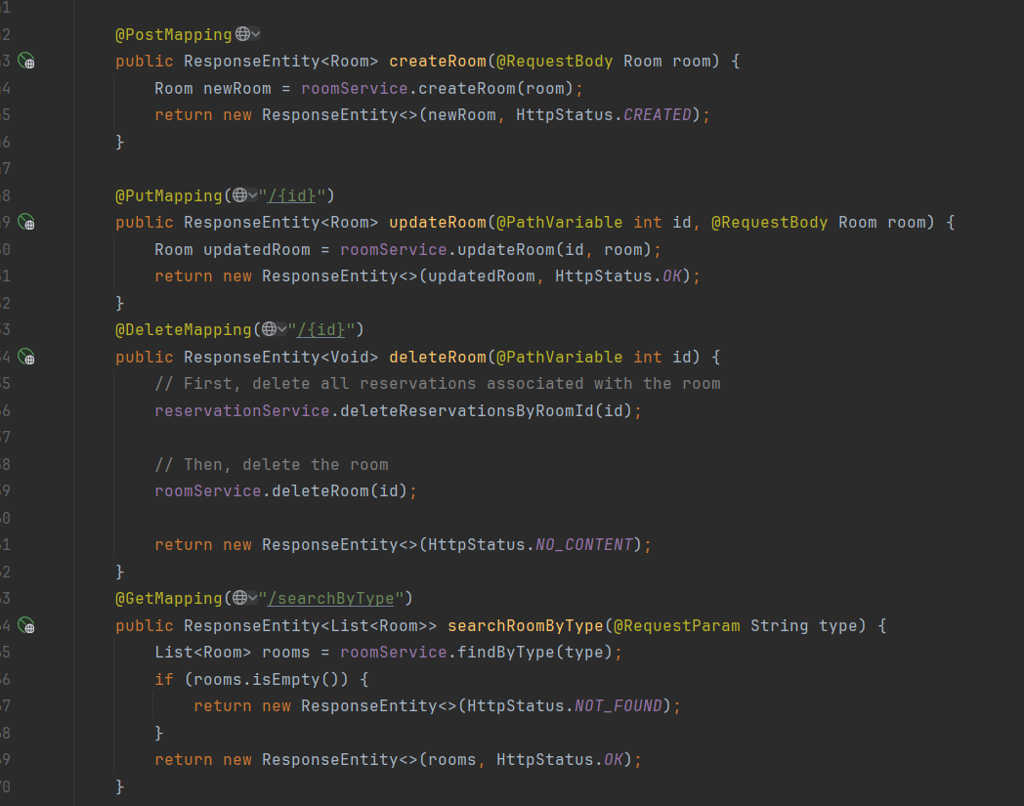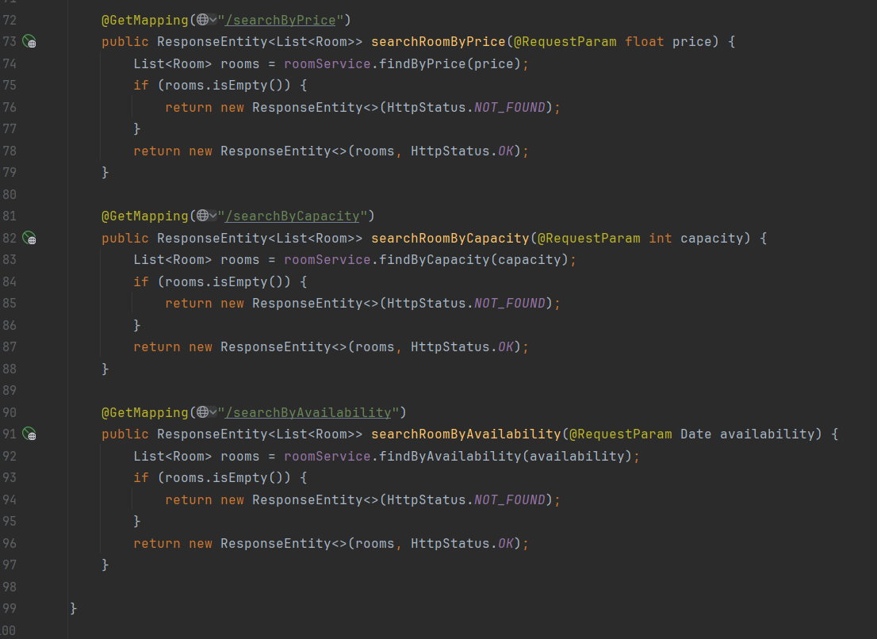

#### Reservation Controller:

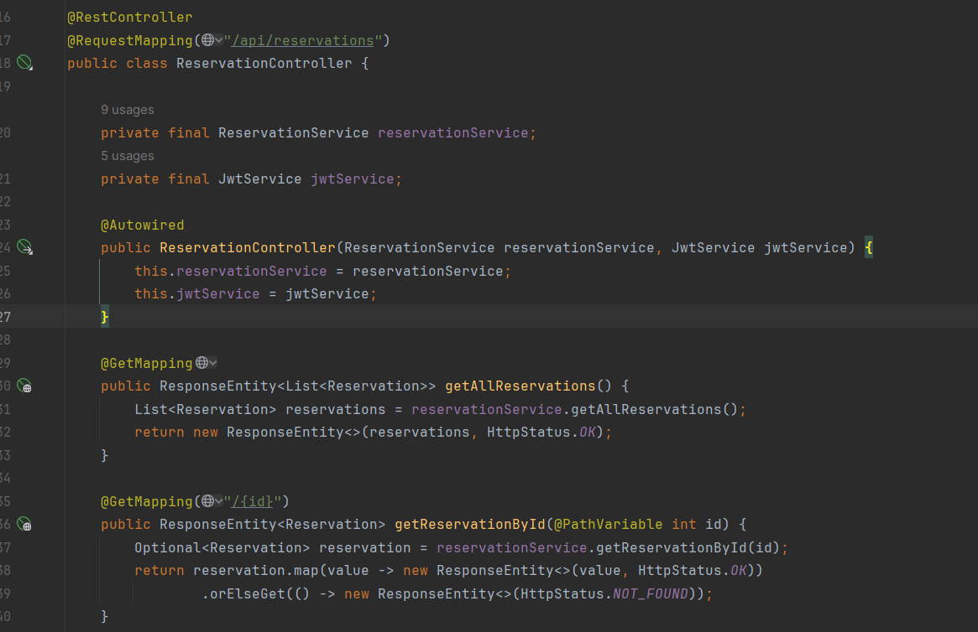 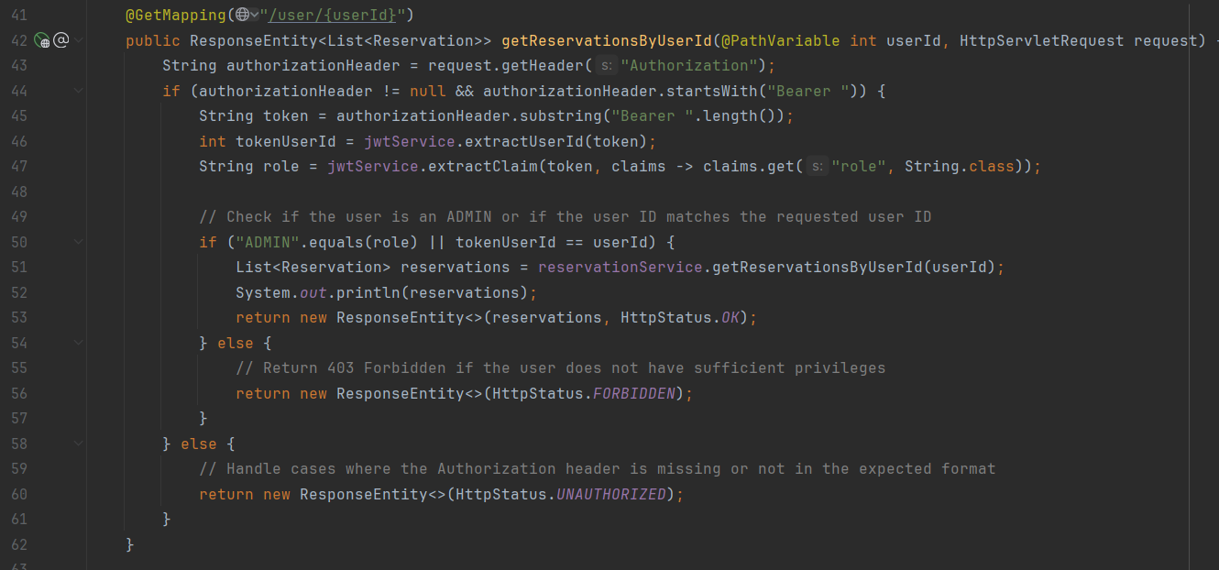 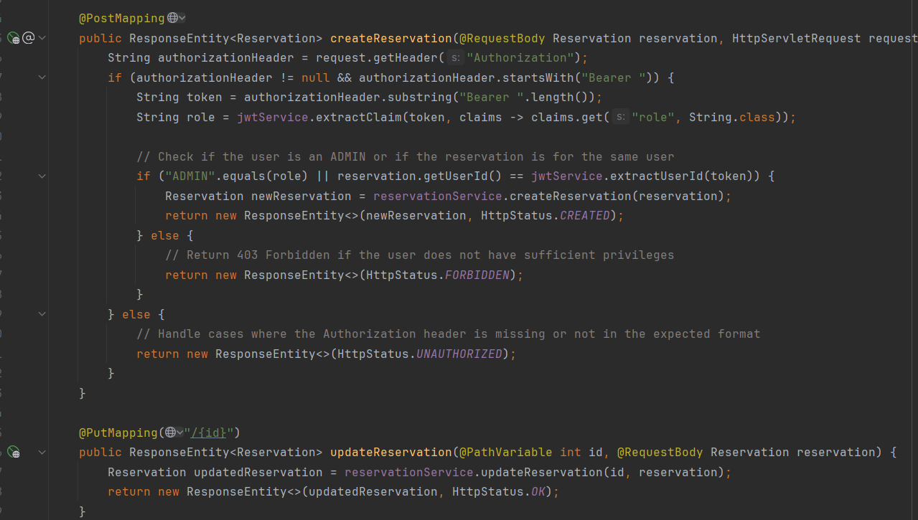 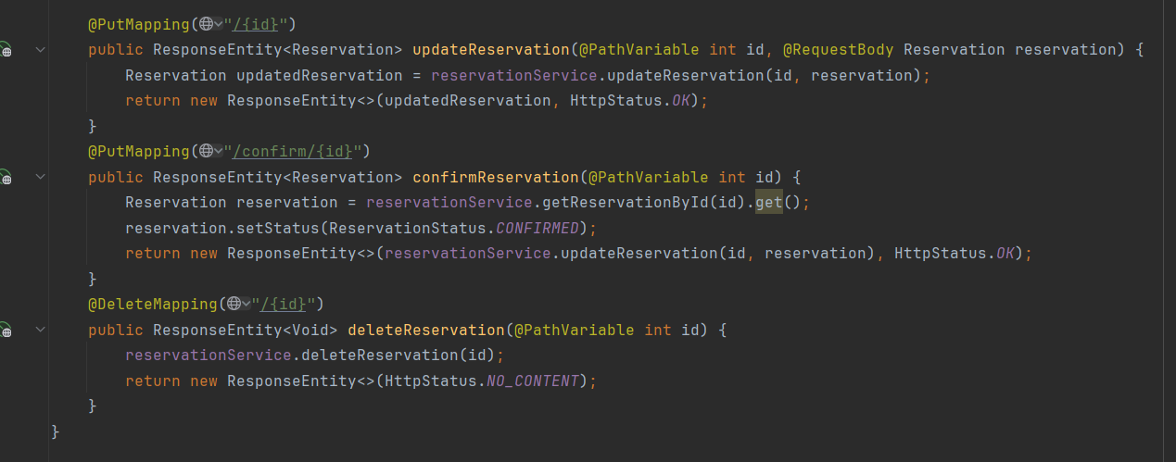

## Security Configuration:

### Overview:

The security layer of the application is designed to safeguard sensitive data and control access to resources. Leveraging Spring Security, a robust authentication and authorization mechanism is implemented. This includes the use of JSON Web Tokens (JWT) for stateless authentication, ensuring secure communication between the client and server. Additionally, a custom WebSecurityConfiguration class is created to define access rules for various endpoints, restricting unauthorized access and enforcing role-based authorization. The configuration includes provisions for user authentication, password encryption using BCrypt, and session management policies to maintain statelessness. Furthermore, a JwtAuthenticationFilter is integrated into the filter chain to intercept incoming requests, validate JWT tokens, and authenticate users before allowing access to protected resources.

### WebConfigurationSecurity.java:

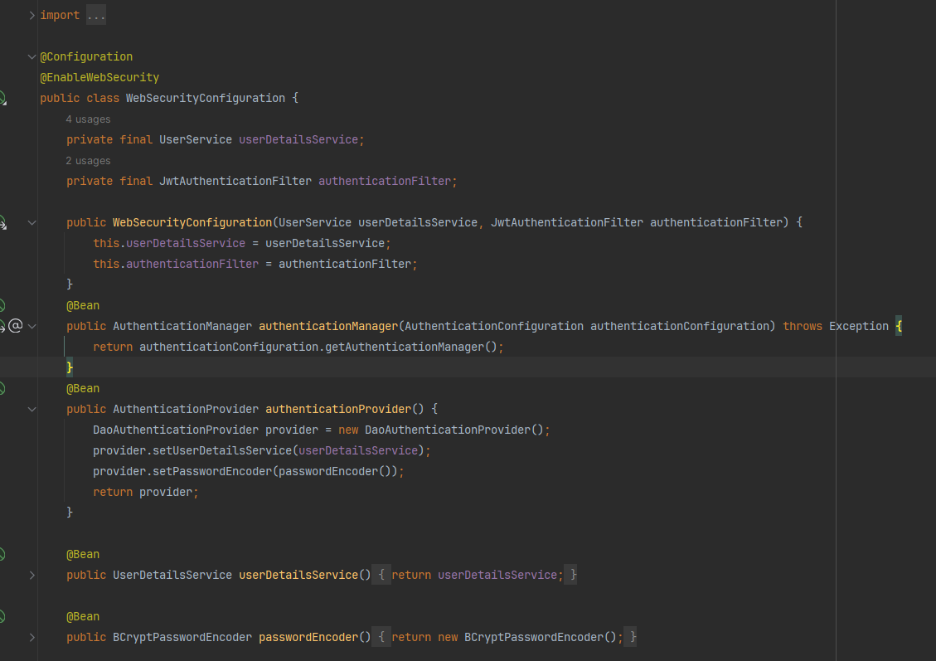 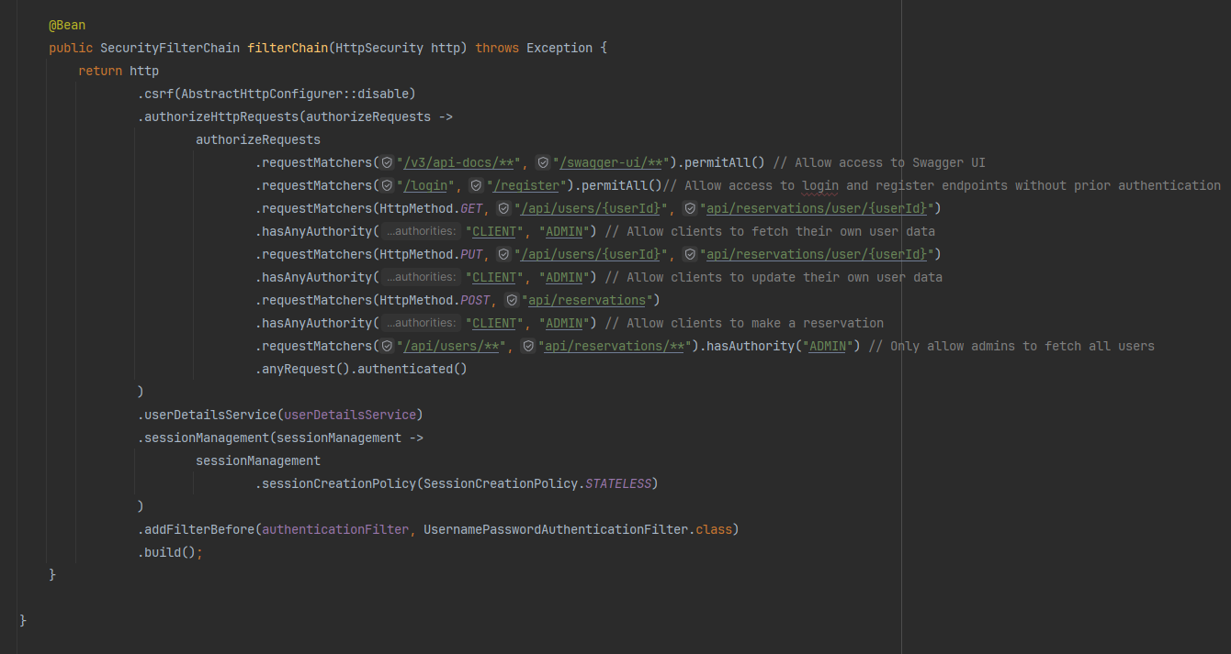

The **WebSecurityConfiguration** class is a pivotal component responsible for configuring security settings within the Spring application. Let's break down its different parts:

#### Annotations:

- **@Configuration**: Indicates that the class contains configuration beans for the application context.

- **@EnableWebSecurity**: Enables Spring Security's web security support and provides integration with Spring MVC.

#### Constructor:

- Initializes the **WebSecurityConfiguration** with dependencies such as the **UserService** and **JwtAuthenticationFilter**.

#### AuthenticationManager Bean:

- The **authenticationManager** bean retrieves the **AuthenticationManager** from the **AuthenticationConfiguration**. This bean is crucial for initiating the authentication process.

#### AuthenticationProvider Bean:

- Defines an **authenticationProvider** bean responsible for authenticating users. It uses a **DaoAuthenticationProvider** implementation, which verifies user credentials against the `**UserService**` and encodes passwords using a **BCryptPasswordEncoder**.

#### SecurityFilterChain Bean:

- Configures the security filter chain using the **filterChain** bean. This chain determines how incoming requests are processed and secured.

- Disables CSRF protection.

- Defines authorization rules using **authorizeHttpRequests**. These rules specify which endpoints are accessible to different types of users based on their roles.

- Configures session management to be stateless, ensuring that the application does not store session information on the server.

- Adds the **JwtAuthenticationFilter** before the **UsernamePasswordAuthenticationFilter** in the filter chain to authenticate requests using JWT tokens.

#### UserDetailsService Bean:

- Creates a **userDetailsService** bean that returns the **UserService**, which is used for loading user-specific data during authentication.

#### PasswordEncoder Bean:

- Creates a **BCryptPasswordEncoder** bean used for encoding passwords securely.

### Registration & Authentication:

#### Overview:

In implementing authentication and authorization using JSON Web Tokens (JWT) in the Spring Boot application, a structured process was followed to ensure secure user interactions. Firstly, the **JwtService** was developed to handle token generation, extraction, and validation. This service provided the backbone for JWT functionality, ensuring that tokens were securely generated and verified. The **AuthenticationService** then utilized this service to facilitate user registration and authentication processes.

Through interactions with the UserRepository, user data was managed securely, with passwords being encrypted before storage. The **JwtAuthenticationFilter** played a crucial role in intercepting incoming requests, extracting JWT tokens, and validating them against user information stored in the database. Successful validation resulted in the establishment of user authentication, allowing authorized access to protected resources.

Finally, the **AuthenticationController** exposed endpoints for user registration and login, serving as the entry point for user authentication operations. This comprehensive approach to authentication and authorization ensured that user interactions within the application were securely managed and protected against unauthorized access.

#### JWT Service:

This Service is used in order to generate and validate tokens that are issued to the users of the application:

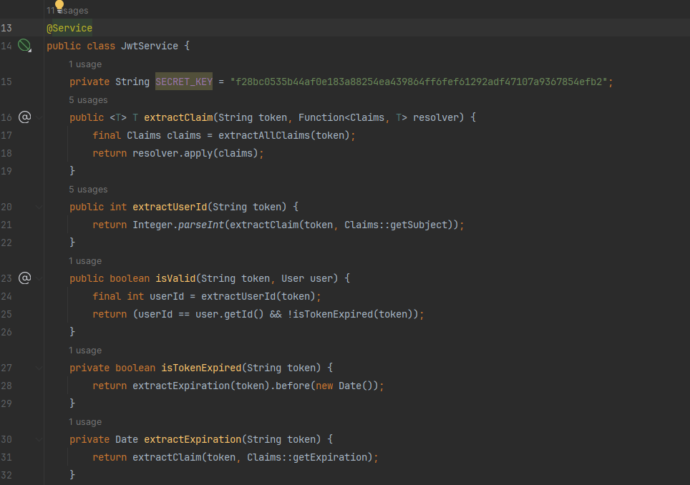

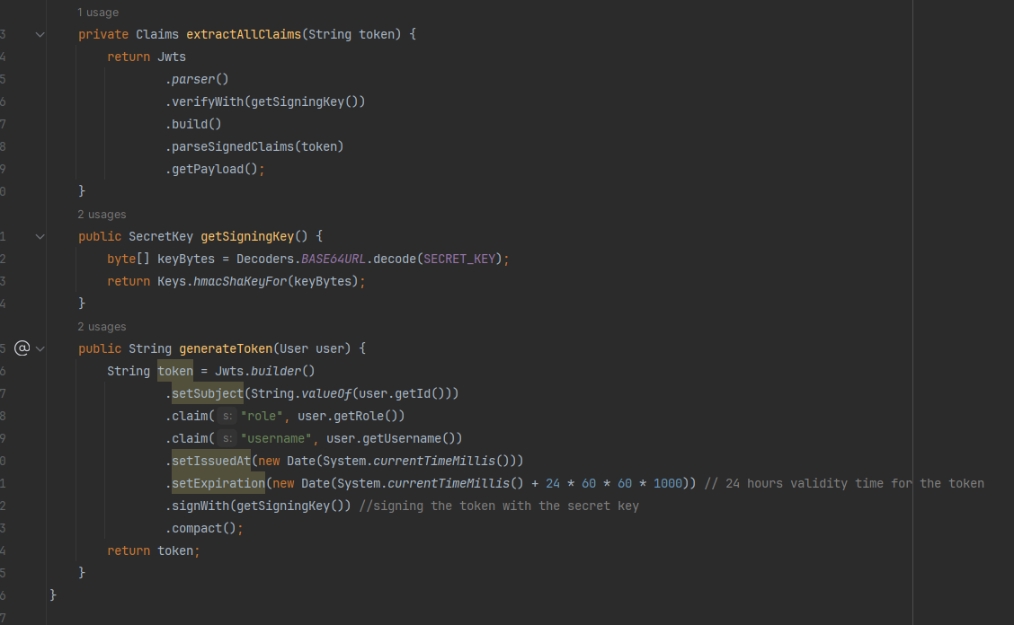

#### AuthenticationService:

This service class manages user authentication and registration processes.

It interacts with the UserRepository to perform user-related operations.

It utilizes JwtService to generate and validate JWT tokens for authenticated users. 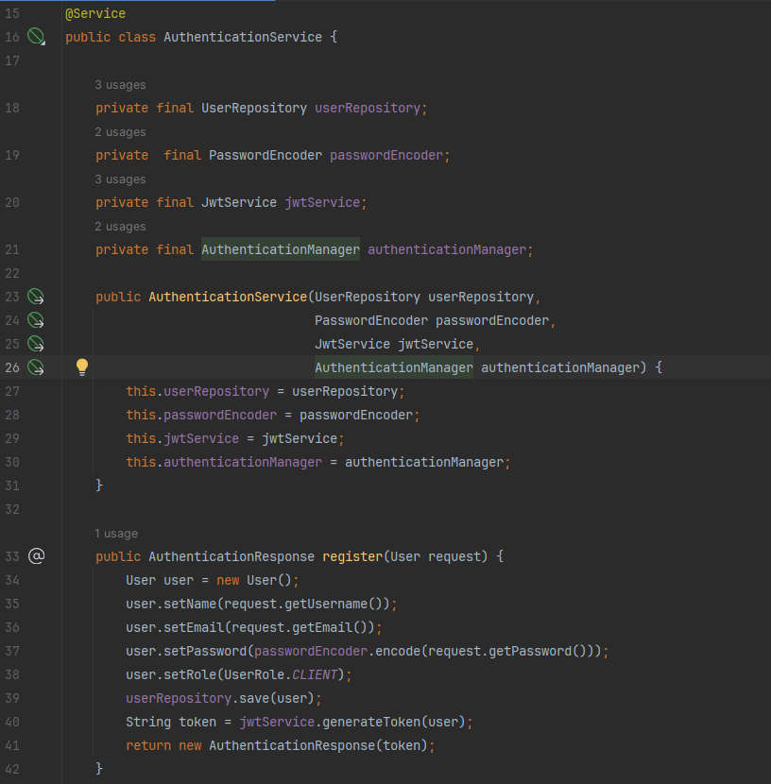

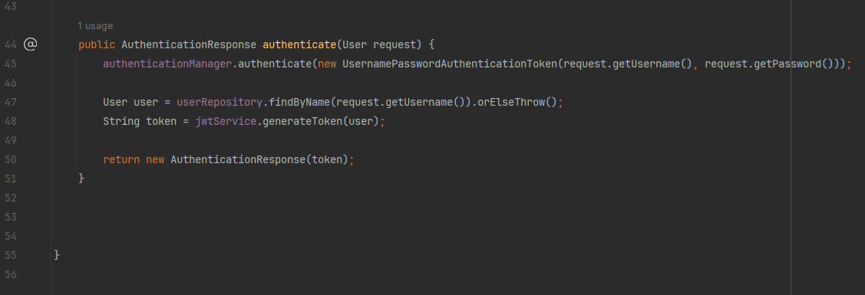

#### AuthenticationResponse:

This simple model class represents the response containing the JWT token generated during authentication.

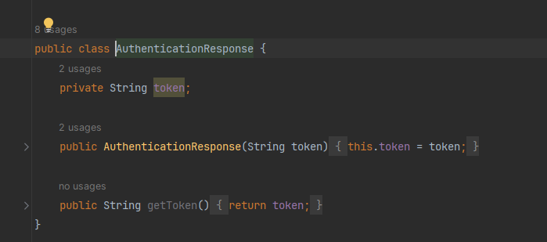

#### JwtAuthenticationFilter:

This filter intercepts incoming requests and extracts JWT tokens from the Authorization header.

It uses JwtService to validate the tokens and authenticate users.

Upon successful authentication, it sets the authentication details in the SecurityContextHolder.

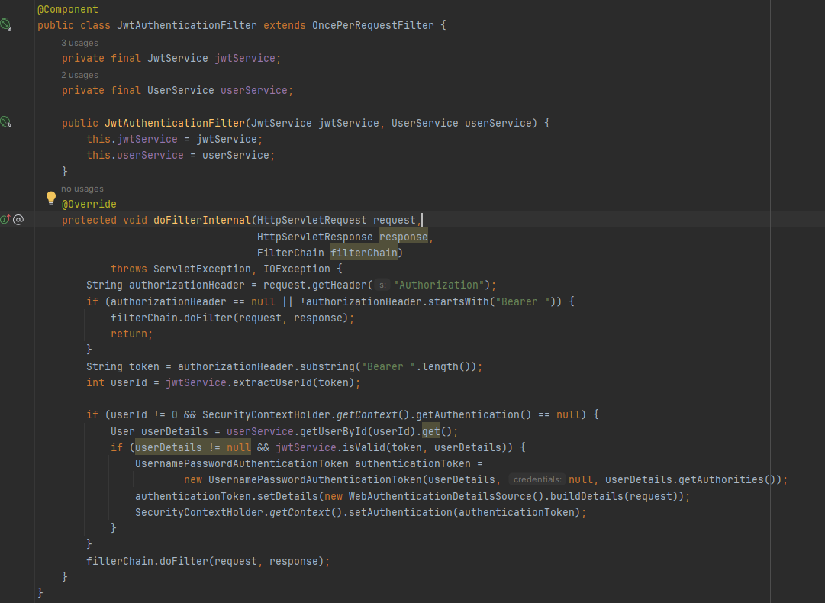

#### AuthenticationController:

This controller class defines endpoints for user registration and login.

It interacts with the AuthenticationService to handle registration and authentication requests.

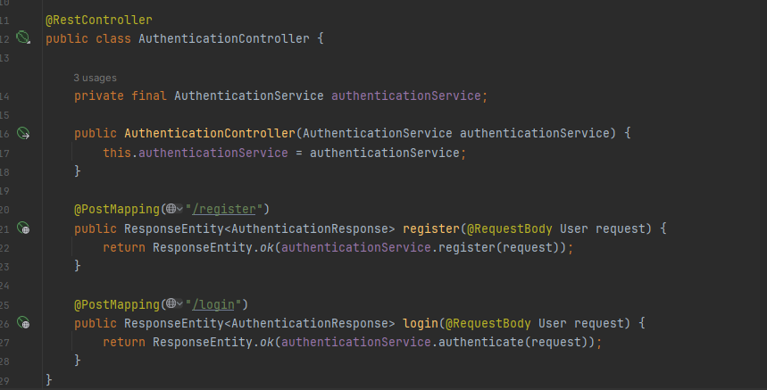

# *API Testing with Swagger & Postman :*

## Swagger:

Swagger was integrated into the Spring Boot application to provide interactive documentation for the RESTful APIs. This simplified access to detailed endpoint information, request parameters, and authentication requirements. With Swagger, developers could efficiently test and explore APIs directly from the Swagger UI, improving development workflow and collaboration.

### Integration:

I integrated Swagger into the application simply by adding the necessary dependency in my **pom.xml** file : 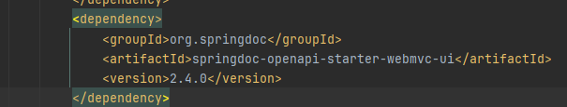

Then I made the swagger endpoint accessible in the **WebSecurityConfiguration** class:

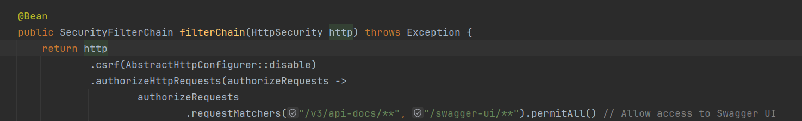

And finally after we run the application and head to this swagger specific URL:[**http://localhost:8080/swagger-ui/index.html**](http://localhost:8080/swagger-ui/index.html)we can view all our available endpoints as well as specific information for each endpoint such as input and output format

### Showcase:

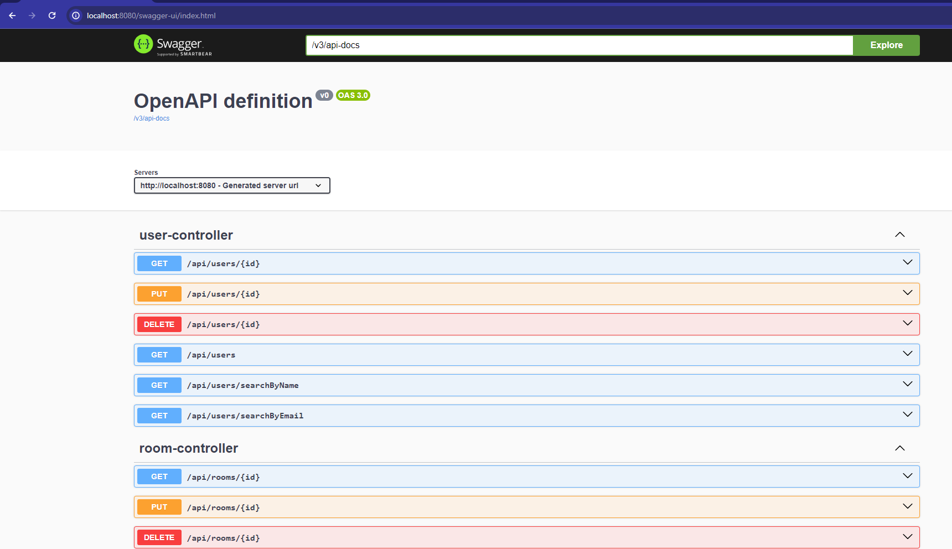 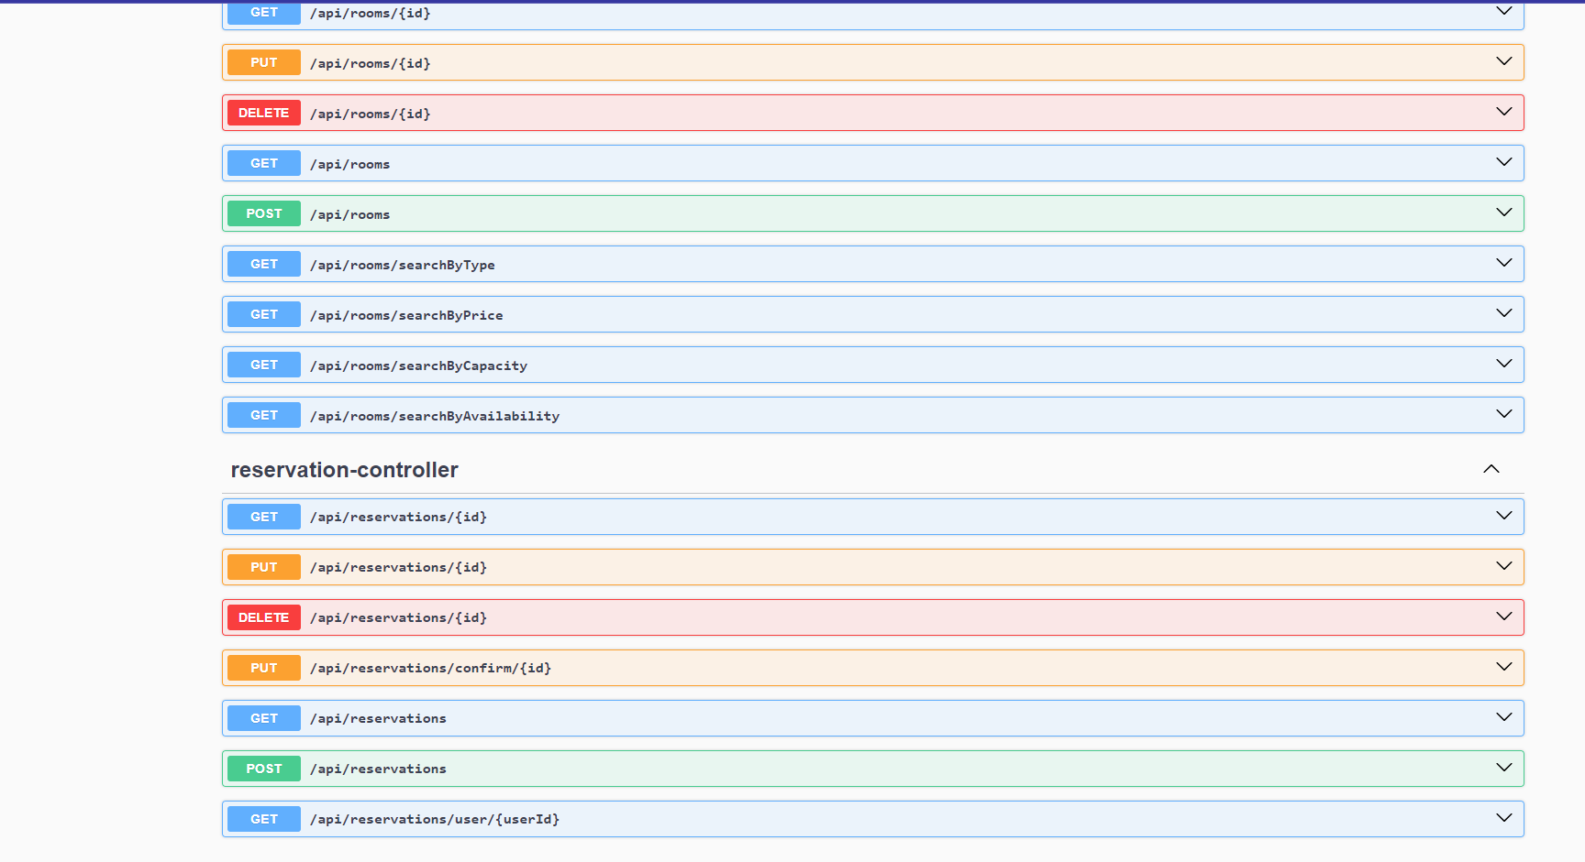 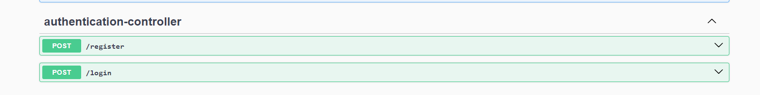

## Postman:

To ensure the functionality and reliability of the implemented APIs, Postman was employed as the primary testing tool. With Postman, a comprehensive suite of API tests was devised, covering various endpoints and scenarios. Each API endpoint was meticulously tested for correct behavior, including successful responses as well as error handling. Parameters such as request bodies, query parameters, and headers were systematically validated to ensure proper integration with the backend services. Additionally, different HTTP methods were employed to simulate diverse user interactions, such as GET requests for fetching data and POST requests for creating resources. Through iterative testing cycles and meticulous validation, the APIs were rigorously examined to guarantee robustness and adherence to the specified requirements.

Here is the link to the collection I published so you can view them directly:

<https://documenter.getpostman.com/view/33858694/2sA35HY28Y>

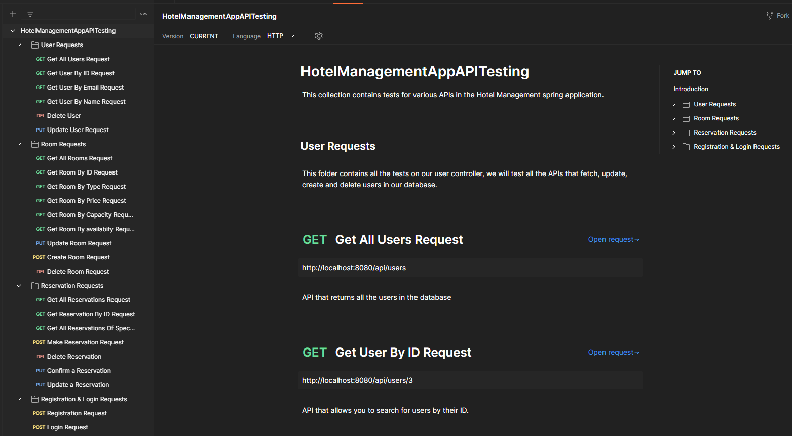

# *Frontend Layer :*

## Connection with the Backend:

In order to HTTP requests to be send from the frontend part to the backend part I added a bean that explicitly allows GET, PUT, POST and DELETE requests from my frontend URI :

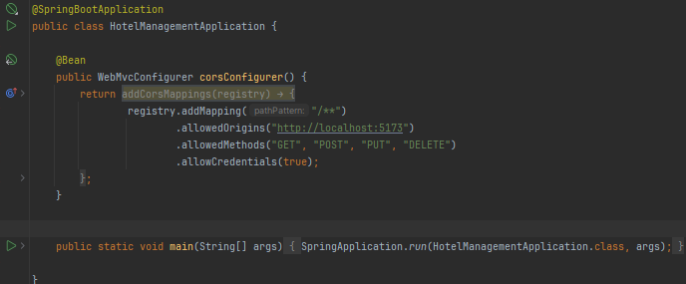

## Showcase:

